Nominal Predicate

✅ What Is a Nominal Predicate?
# Source: AI Source: Provided by: [Data Path: Persons Table -> ID Column: 1, Name_En Column: Motasem Essam] -> From: [ChatGPT] on [8/4/2025]
A Nominal Predicate (also called a predicate with a subject complement) is a predicate that uses a linking verb to connect the subject to a noun or adjective that either renames or describes the subject.

🔸 Key Features:
# Source: AI Source: Provided by: [Data Path: Persons Table -> ID Column: 1, Name_En Column: Motasem Essam] -> From: [ChatGPT] on [8/4/2025]
- Built with a linking verb (e.g., is, are, was, were, become, seem).
- Does not show an action.
- Includes a subject complement, which can be:
  - A noun/pronoun → Predicate Nominative
  - An adjective → Predicate Adjective

🔸 Types of Nominal Predicates:
# Source: AI Source: Provided by: [Data Path: Persons Table -> ID Column: 1, Name_En Column: Motasem Essam] -> From: [ChatGPT] on [8/4/2025]

Sub-Type | Description | Example
Predicate Nominative | Renames the subject (noun/pronoun) | She is a teacher.
Predicate Adjective | Describes the subject (adjective) | He seems tired.

🔸 Examples of Nominal Predicates:
# Source: AI Source: Provided by: [Data Path: Persons Table -> ID Column: 1, Name_En Column: Motasem Essam] -> From: [ChatGPT] on [8/4/2025]
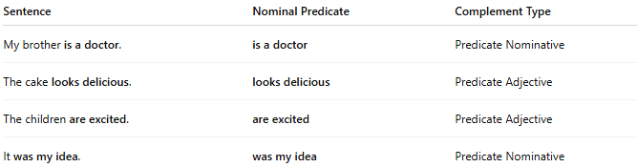
Sentence | Nominal Predicate | Complement Type
My brother is a doctor. | is a doctor | Predicate Nominative
The cake looks delicious. | looks delicious | Predicate Adjective
The children are excited. | are excited | Predicate Adjective
It was my idea. | was my idea | Predicate Nominative

🔸 Compare With Verbal Predicate:
# Source: AI Source: Provided by: [Data Path: Persons Table -> ID Column: 1, Name_En Column: Motasem Essam] -> From: [ChatGPT] on [8/4/2025]

Type | Sentence | Predicate
Verbal Predicate | She writes poems. | writes poems
Nominal Predicate | She is a poet. | is a poet

